1. Creating and Renaming Files/Directories

Create a directory named test_dir using mkdir.

Inside test_dir, create an empty file called example.txt.

Rename example.txt to renamed_example.txt using mv

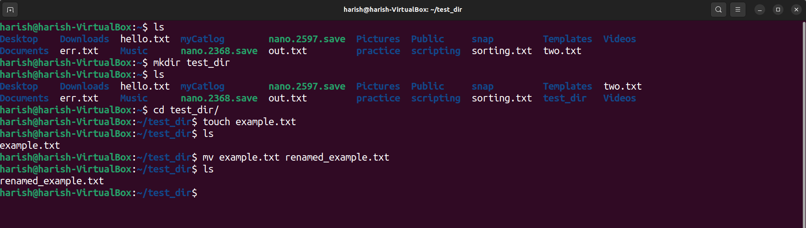

Explanation:

mkdir test_dir 🡪 Creates a new directory with name test_dir

cd test_dir 🡪 to change the directory(go inside the test_dir)

touch example.txt 🡪 creates an empty file with name example.txt

mv example.txt renamed_example.txt 🡪 Rename the example.txt to renamed_example.txt

----------------------------------------------------------------------------------------------------------------------------------------------

2. Viewing File Contents

Use cat to display the contents of /etc/passwd.

Display only the first 5 lines of /etc/passwd using head.

Display only the last 5 lines of /etc/passwd using tail.

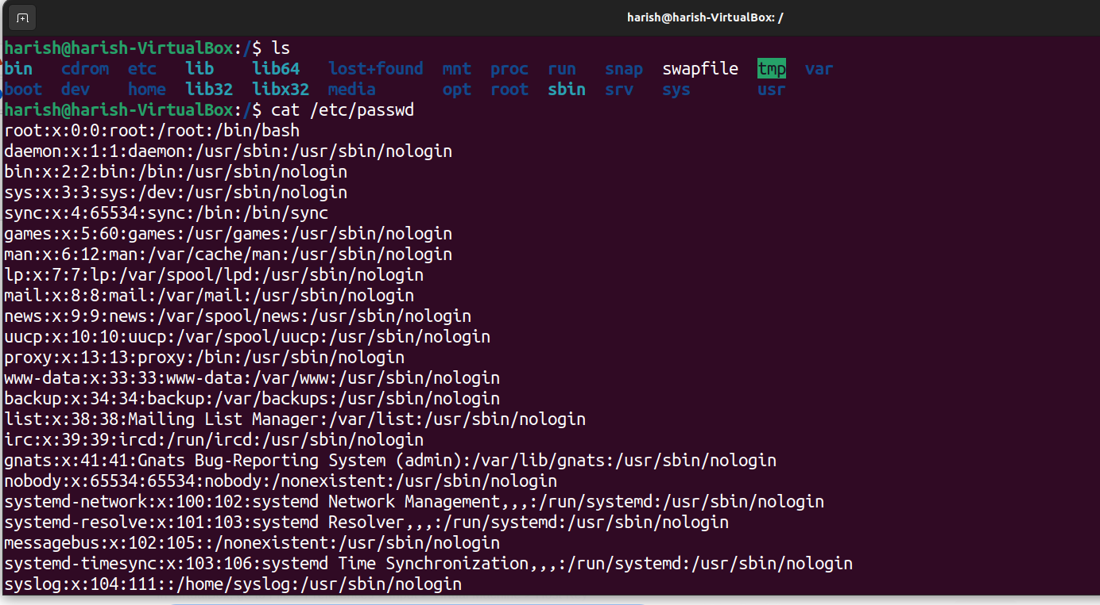

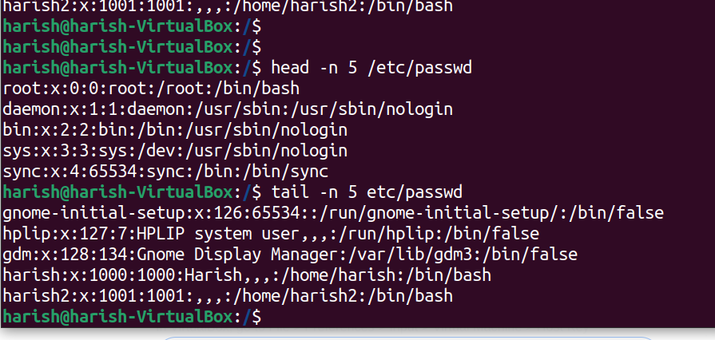

Explanation:

Got to the location where the etc directory is present.

cat /etc/passwd 🡪 shows the complete content.

head –n 5 /etc/passwd 🡪 shows first 5 lines of /etc/passwd

tail –n 5 /etc/passpwd 🡪 shows last 5 lines of /etc/passwd

------------------------------------------------------------------------------------------------------------------------------------------------

3.Searching for Patterns

Use grep to find all lines containing the word "root" in /etc/passwd.

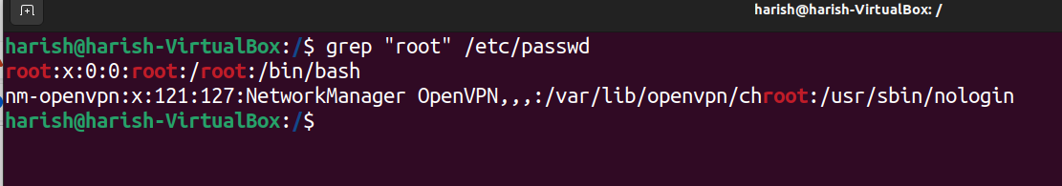

Explanation:

grep “root” /etc/passwd 🡪 display lines containing word “root”

--------------------------------------------------------------------------------------------------------------------------------------------

4. Zipping and Unzipping

Compress the test_dir directory into a file named test_dir.zip using zip.

Unzip test_dir.zip into a new directory named unzipped_dir.

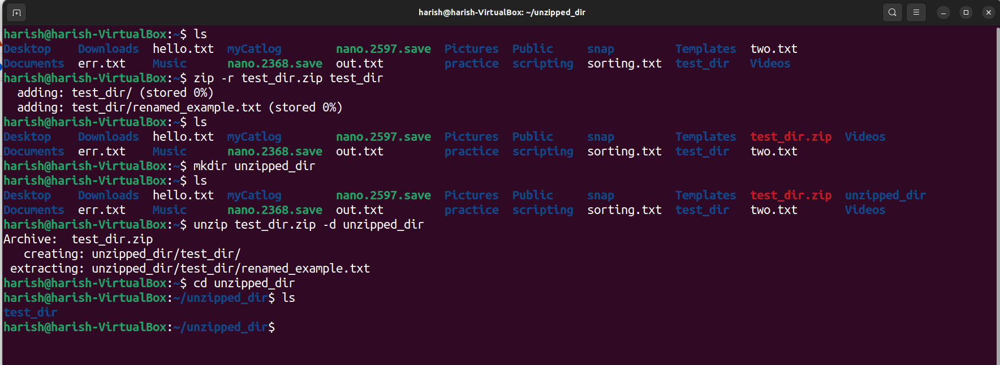

Explanation:

zip –r test_dir.zip test_dir 🡪 compress test_dir to text_dir.zip

mkdir unzipped_dir 🡪 create a directory with name unzipped_dir

unzip test_dir.zip –d unzip_dir 🡪 unzip the test_dir.zip to test_dir inside unzipped_dir

-------------------------------------------------------------------------------------------------------------------------------------------------

5. Downloading Files

Use wget to download a file from a URL (e.g., <https://example.com/sample.txt>).

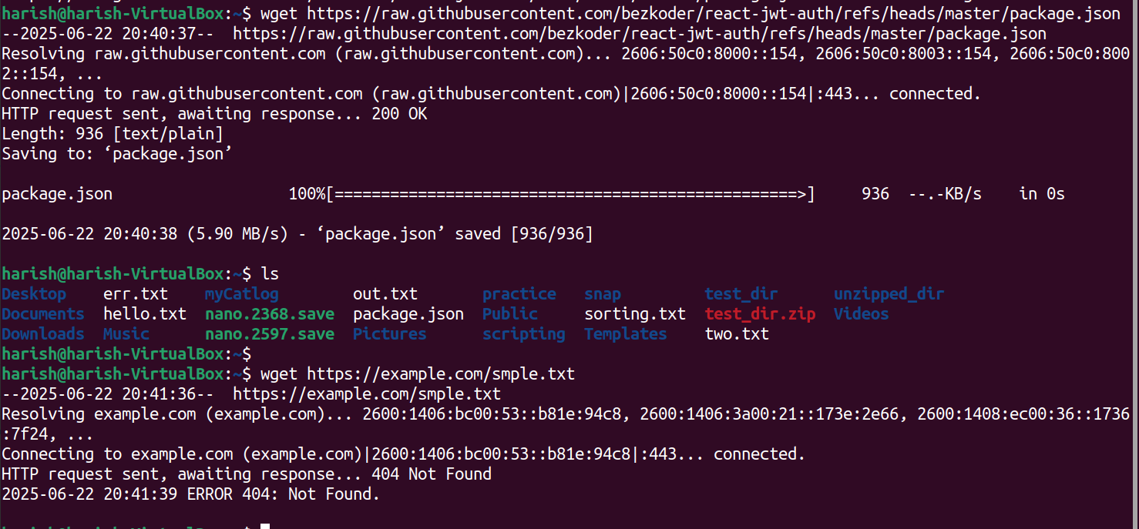

Explanation:

wget <https://example.com/sample.txt> 🡪 giving not found

---------------------------------------------------------------------------------------------------------------------

6.Changing permissions

Create a file named secure.txt and change its permissions to read-only for everyone using chmod.

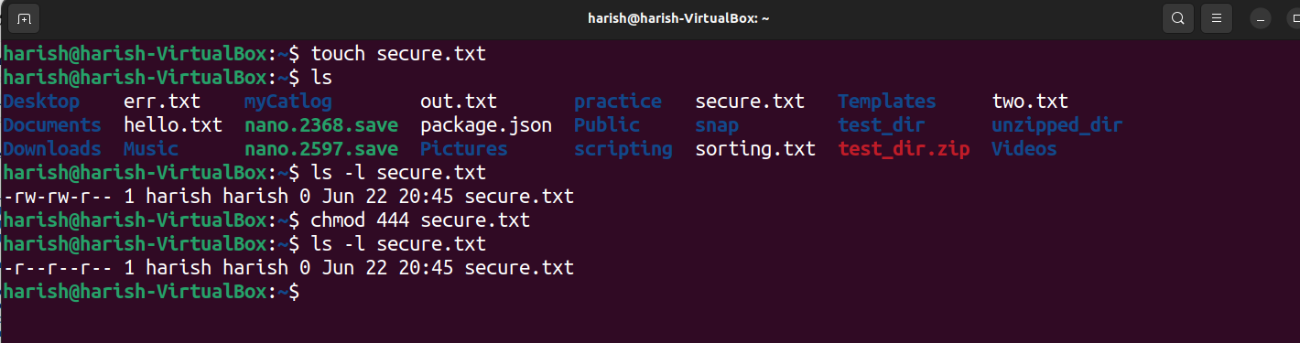

Explanation:

touch secure.txt 🡪 create an empty file with name secure.txt

chmod 444 secure.txt 🡪 change permission to read-only

ls –l secure.txt 🡪 to verify the permission.

------------------------------------------------------------------------------------------------------------------------------------------

7. working with Environment Variables.

Use export to set a new environment variable called MY_VAR with the value "Hello, Linux!".

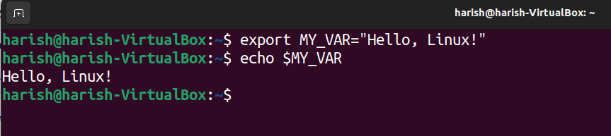

Explanation:

export MY_VAR=”Hello, Linux!” 🡪 create an environment variable with name MY_VAR.

echo $MY_VAR 🡪 shows the value of environment variable.